Real Fake Doors

European Market Expansion Proposal

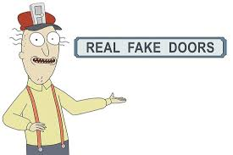

323 E. West Avenue
Seattle, WA 98101

Table of Contents (Brandon Tolar)

Introduction………………………………….. Pg. 3

Rationale & Significance…………………….. Pg. 3

Plan of Work…………………………………. Pg. 4

Task Breakdown……………………………… Pg. 5

Problem analysis……………………………… Pg. 11

Biosketch…………………………………….. Pg. 13

Cost Proposal………………………………… Pg. 14

Conclusion…………………………………… Pg. 15

References…………………………………… Pg. 16

Project Summary (Khai Lim)

The Real Fake Door proposal will help both side earn the benefit received the best quality with low cost. Our company proposal give opportunity to another company earn the profit. Our company are looking for a partner able to help us to expand a market in European to create benefit for both.

Introduction (Nikolaus Kreiling)

Real Fake Doors has always been a strictly American company. We source all of our resources in the USA, we hire all of our workers within the country, and we sell to anyone in America who wants to purchase our products. This report indicates a major stepping stone for Real Fake Doors as we attempt to widen our market to include all of the countries within the European Union. With this proposal we intend to enter the European Market in order to satisfy all of our friends across the pond who have expressed interest in our products.

Rational/Significance (Nikolaus Kreiling)

Over the last year and a half Real Fake Doors has received an increasing number of requests from members of the European market to purchase our products. We have recently started fulfilling some of the larger requests and adding large shipping fees to pay for the costs to ship across the ocean. European requests have gotten so numerous that we have decided the most effective way to fulfill them is if we actually occupy the European Market.

Our occupation of the European market will consist of purchasing a factory in Greece. With this factory we will be able to build, produce, and ship Real Fake Doors products to anywhere in the European Union. We are going to source our products from within the European Union as well in order to keep costs and environmental impact as low as possible. This proposal will result in a massive increase in sales and profit as we begin to populate the European market with Real Fake Doors.

Plan of Work (Nikolaus Kreiling)
Scope
The factory that Real Fake Doors intends to purchase will be located in Komotini, Greece. Komotini is a city in northern Greece. This northern location will allow easier shipping throughout the European Union. The factory’s location is also intended to assist in jumpstarting Greece’s economy. Real Fake Doors intends to hire primarily Grecian citizens within the new factory in order to help boost the workforce in Greece. We will also be employing a Greece-based shipping company to fulfill the vast majority of our orders in Southern Europe. These Grecian workers in addition to the taxes that Real Fake Doors will be paying towards the government in Greece should help jumpstart Greece’s economy and hopefully assist the economy’s future growth.

Factory Location
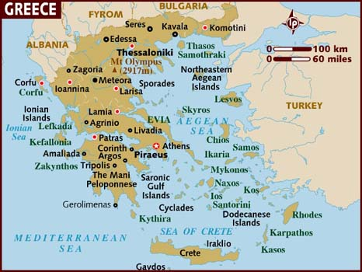
Note: Komotini is the location of Real Fake Doors’ new factory. Komotini is a red dot surrounded by a white circle located in Northeastern Greece.

Methods
Real Fake Doors will be purchasing an existing factory in Komotini, Greece. The factory’s location in northern Greece will make it optimal for shipping products to the rest of Europe. The factory will need to be outfitted with machinery in order to fit the needs of the Real Fake Doors manufacturing team. Once the factory has been renovated and outfitted (approximately two months) manufacturing supplies will be moved from their current location in a storage facility to the factory production can begin. We anticipate that we can begin fulfilling European orders within one week of our production start date.

Task Breakdown ( Khai Lim)
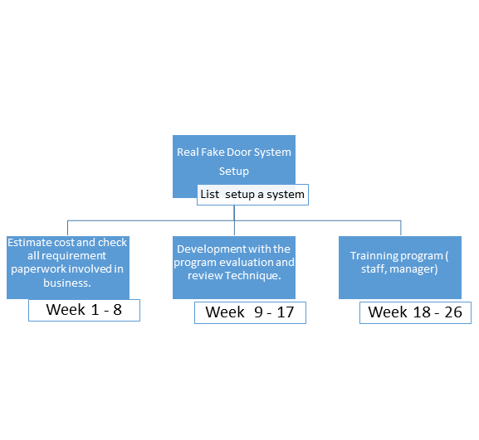

Business Start-up ( Khai Lim)

Task # | List name | Estimate time | Number need | position
1 | Strategic Plan | 30 days
2 | Self-Assessment | 5 days
3 | Define business vision | 1 day |  | Manager
4 | Identify available skills, information and support | 1 day | 3 | Advisor, Manager
5 | Decide whether to proceed | 1 day | 4 | Manager
6 | Define the Opportunity | 10 days
7 | Research the market and competition | 1 day | 5 | Advisor
8 | Interview owners of similar businesses | 5 days | 7 | Owners
9 | Identify needed resources | 2 days | 8 | Advisor, Peers
10 | Identify operating cost elements | 2 days | 9 | Accountant
11 | Evaluate Business Approach | 4 days
12 | Define new entity requirements | 1 day | 10 | Manager
13 | Identify on-going business purchase opportunities | 1 day | 12 | Manager
14 | Research franchise possibilities | 1 day | 13 | Manager
15 | Summarize business approach | 1 day | 14 | Manager
16 | Evaluate Potential Risks and Rewards | 7 days
17 | Assess market size and stability | 2 days | 12 | Advisor
18 | Estimate the competition | 1 day | 17 | Advisor
19 | Assess needed resource availability | 2 days | 18 | Advisor
20 | Evaluate realistic initial market share | 1 day | 19 | Advisor
21 | Determine financial requirements | 2 days | 15 | Advisor
22 | Review personal suitability | 1 day | 21 | Manager
23 | Evaluate initial profitability | 1 day | 22 | Manager
24 | Review and modify the strategic plan | 2 days | 23
25 | Confirm decision to proceed | 0 days | 24
26 | Phase 2 - Define the Business Opportunity | 27 days
27 | Define the Market | 13 days
28 | Access available information | 1 day | 25 | Advisor
29 | Create market analysis plan | 2 days | 28 | Advisor
30 | Implement market analysis plan | 5 days | 29 | Advisor
31 | Identify competition | 2 days | 30 | Advisor
32 | Summarize the market | 2 days | 31 | Advisor
33 | Identify target market niche | 1 day | 32 | Advisor
34 | Identify Needed Materials and Supplies | 7 days
35 | Select a business approach (from "Evaluate Business Approach" above) | 2 days | 28SS, 33 | Manager
36 | Identify management staff resources | 1 day | 35 | Manager
37 | Identify staffing requirements | 1 day | 36 | Manager
38 | Identify needed raw materials | 1 day | 37 | Manager
39 | Identify needed utilities | 1 day | 38 | Manager
40 | Summarize operating expenses and financial projections | 1 day | 39 | Manager
41 | Evaluate Potential Risks and Rewards | 6 days
42 | Assess market size and stability | 2 days | 40 | Manager
43 | Assess needed resources availability | 2 days | 42 | Manager
44 | Forecast financial returns | 2 days | 43 | Accountant
45 | Review and modify the business opportunity | 1 day | 44
46 | Confirm decision to proceed | 0 days | 45 | Advisor, Peers, Lawyer, Accountant
47 | Phase 3 - Plan for Action | 21 days
48 | Develop Detailed 5-Year Business Plan | 21 days
49 | Describe the vision and opportunity | 1 day | 46 | Advisor
50 | List assumptions | 1 day | 49 | Advisor
51 | Describe the market | 1 day | 50 | Advisor
52 | Describe the new business | 1 day | 51 | Advisor
53 | Describe strengths, weaknesses, assets and threats | 1 day | 52 | Advisor
54 | Estimate sales volume during startup period | 1 day | 53 | Advisor, Accountant
55 | Forecast operating costs | 1 day | 54 | Advisor, Accountant
56 | Establish pricing strategy | 1 day | 55 | Advisor
57 | Forecast revenue | 1 day | 56 | Advisor
58 | Summarize pro-forma financial statement | 2 days | 57 | Advisor
59 | Develop break-even analysis | 1 day | 58 | Advisor
60 | Develop cash-flow projection | 1 day | 59 | Advisor
61 | Identify licensing and permitting requirements | 1 day | 60 | Advisor
62 | Develop startup plan | 2 days | 61 | Advisor
63 | Develop sales and marketing strategy | 1 day | 62 | Advisor
64 | Develop distribution structure | 1 day | 63 | Advisor
65 | Describe risks and opportunities | 2 days | 64 | Advisor
66 | Publish the business plan | 1 day | 65 | Advisor
67 | Confirm decision to proceed | 0 days | 66 | Advisor
68 | Phase 4 - Proceed With Startup Plan | 53 days
69 | Choose a location | 1 day | 67
70 | Establish Business Structure | 24 days
71 | Choose a Name | 2 days
72 | Identify implications | 1 day | 69 | Lawyer
73 | Research name availability | 1 day | 72 | Lawyer
74 | Choose a Bank | 5 days
75 | Establish accounts | 4 days | 73 | Banker
76 | Establish line of credit | 1 day | 75 | Banker
77 | Choose legal representation | 1 day | 75SS, 76 | Lawyer
78 | Select business tax-basis category | 2 days | 77 | Lawyer, Accountant
79 | Choose capital funding source | 2 days | 78 | Manager
80 | Commit capital funding | 0 days | 79 | Manager
81 | Establish the Operating Control Base | 12 days
82 | Choose and set up the accounting system | 2 days | 79, 80 | Accountant
83 | Obtain required licenses and permits | 4 days | 82 | Lawyer, Government agency
84 | Obtain needed insurance | 4 days | 83 | Accountant
85 | Establish security plan | 2 days | 84 | Advisor, Lawyer
86 | Develop Marketing Program | 4 days
87 | Establish an advertising program | 2 days | 73SS | Advisor
88 | Develop a logo | 1 day | 87 | Advisor, Lawyer
89 | Order promotional materials | 1 day | 88 | Advisor
90 | Provide Physical Facilities | 15 days
91 | Secure operation space | 5 days | 85, 89 | Lawyer
92 | Select computer network hardware | 1 day | 91 | Information services
93 | Select computer software | 1 day | 92 | Information services
94 | Establish utilities | 3 days | 93 | Manager
95 | Provide furniture and equipment | 4 days | 94 | Manager
96 | Move in | 1 day | 95 | Manager
97 | Provide Staffing | 40 days
98 | Interview and test candidates | 14 days | 79 | Manager
99 | Hire staff | 10 days | 98 | Manager
100 | Train staff | 16 days | 99 | Manager
101 | Start up the business | 0 days | 96-100 | Manager

Problem Analysis (Austin Young)
Several problems may arise with our expansion into a European market. These problems can slow down or possibly even halt our expansion:

- Inefficient management: Expanding so quickly will require us to hire new management to oversee operations in Europe. Quickly hiring people for this position may result in poor management due to hiring people that are not fully qualified or do not have enough experience for the job. To avoid this, we must ensure that we have a strict hiring process.

- Lack of experienced workers: There is the possibility that there will not be enough workers to hire that possess the required experience for the job. An intense training program could be started for inexperienced workers, but this would delay how long it will take before we are able to make doors.
- High tax rates: Tax rates in Greece are very high which will greatly affect our ability to make a large profit. It can also make it hard to acquire material to build our doors.

- Unfamiliar market: Since our company has very little experience in this market, we will most likely initially struggle to gain a footing in Europe. Factors like resource availability, resource price and product demand might affect might affect how many door we can produce and how many doors we can sell.

- Competition: There will ultimately be competition in the European market. Since we are the newcomer there, we will have to fight to establish ourselves as a company that produces the highest quality doors and can meet any demand for our doors.

- Language Barriers: With us creating a factory in Greece, there might be trouble with communicated between management or between workers. Because of this, English speaking employees will most likely have to learn Greek as it is the language most employees there will be speaking. If the head executive at our European branch is unable to speak both English and Greek, a translator will be required. Translation might also lead to failure in following instructions because demands could be lost in translation.

Biosketch (Brandon Tolar)
Brandon Tolar
- B.A. in Business Marketing from Princeton University
- 5 Years business management experience
- Fluent Greek/Bulgarian speaker
Khai Lim
- B.S. in International Business from Harvard Business School
- 2 years business management experience
Nikolaus Kreiling
- M.S. in Business from Harvard Business School
- 10 years business management experience
- 4 years senior management position at Real Fake Doors
Austin Young
- B.A. in Accounting from Harvard Business School
- 4 years accounting experience
- Fluent Turkish speaker
Jack Hitchcock
- B.S. in Mechanical Engineering from MIT
- Lead engineer on Real Fake doors Washington factory redesign
- Fluent Greek speaker

Budget (Jack Hitchcock)
Considering the decision to expand to a European market, this budget will be expensive and also meticulous. Many variable factors come into play when choosing to expand a company overseas. For starters, you will need a factory to produce Real Fake Doors in the European country that is selected. On average, our factories will cost about $150,000 to build, with another $1,000 per month in property rent. The hemp material required to make our doors will run about $10,000 to produce enough supply to fill our first year’s supply, roughly 100 doors. Since we have improved our doors with new hemp material to increase durability in water, doors cost about $100 per door to make. Along with the factory, we will purchase machinery and hire employees to run the machinery and help make the doors. The machinery to produce our Real Fake Doors will be an estimated $50,000. To start, we will hire 75 employees to run the factory, with a starting pay of $10/hour. Assuming each employee is working 40 hours a week, it will cost roughly $30,000 per week. As of now, start-up cost will include factory cost, property rent, material cost, machinery and workers’ pay.
· Factory: $150,000
· Property Tax: $1,000/month ($12,000 annually)
· Materials: $10,000
· Machinery: $50,000
· Employee Cost: $30,000 per week ($360,000 annually)
The first year will total roughly $582,000. This number may vary per year, based on the amount of doors we will sell, the amount of workers we hire, annual raises for employees, etc. We will expect to spend about $600,000 for start-up costs which covers the first year of business.
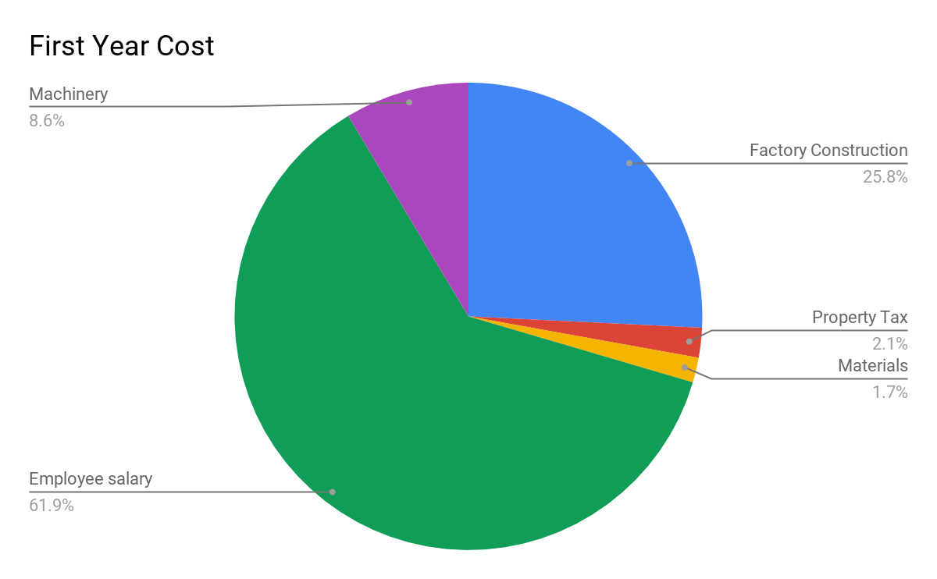
Conclusion (Nikolaus Kreiling)

As discussed throughout this report, Real Fake Doors plans to purchase a factory in Komotini, Greece. This location, while not centralized in Europe, is intended to help jumpstart the economy in Greece and contribute heavily to the regrowth in Greece. We are, in essence, investing in Greece. This location will allow us to ship to southern Europe very easily. Southern Europe contains the majority of the orders we have received so we expect the factory’s southern location in reference with the rest of Europe to be a non-issue.

We expect to be shipping orders within three months of purchasing the factory. Renovating and outfitting should take no more than two months according to the construction companies that have been initially consulted for this project. Once the renovations and outfitting are complete is simply a matter of moving materials into the factory. After the materials required for production of Real Fake Doors are present in the factory production can begin immediately. We already have numerous initial orders to fulfill throughout Greece and Southern Europe so the sooner this project begins the sooner these customers can be fulfilled.

The members of the Real Fake Doors executive board are very excited for this project to begin. Recent calculations have estimated that the company will be have paid for the factory and construction costs within one year of the project’s start date. This means that a year after the factory is purchased we will begin making a profit and benefitting our shareholders. Once the board reads this proposal and the majority votes favorably Real Fake Doors will begin the process of acquiring the new factory. We at Real Fake Doors are very excited for this opportunity and extremely optimistic for the possible outcomes.

References

Picture of Greece:
https://www.lonelyplanet.com/maps/europe/greece/

